

Project on

“FILE HANDLING”

UE25CS151A – PCPS Jackfruit Problem

Submitted by:

ANKITHA S  ANAGHA N UMARANI  ARTHI KULDEEP BIRAJDAR | PES2UG25AM031  PES2UG25AM027  PES2UG25CS091
SECTION -B

Under the guidance of

Prof. vanitha
PES University

Sep - Dec 2025

DEPARTMENT OF COMPUTER SCIENCE AND ENGINEERING
- Problem Statement:

• Merge two text files
• Count errors in a log file
• Read & update student records

- Approach/Methodology/Data structures Used:

- file handling focuses on persistent storage and retrieval of data so that information is not lost when the program terminates.
- The program interacts with files stored on secondary memory (disk) to read, write, update, and delete data efficiently.
- The file handling process follows a structured sequence:
- File Creation / Opening
- Data input
- File Operations
- File Closing
- Error Handling
- File (Primary Data Structure)
Text files – data stored in readable format

- Challenges Faced:

1.Using GUI
2.Fixing indentations
3.Dividing the program in to three parts and getting output separately for each part.

- Scope for Improvement:

Modular Design
Cross-Platform Support
Better Error Handling

- Sample Input/Output:

- #TASK 1
- # INPUT: FOR MERGING TWO TEXT FILES
- 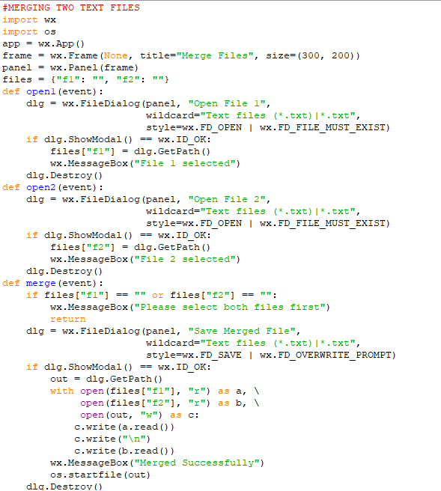
- 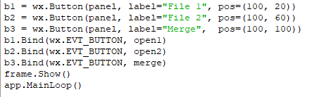

- #OUTPUT OF MERGING TWO TEXT FILES
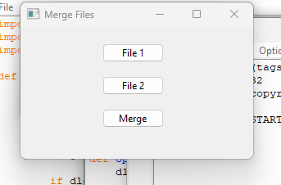

- MERGED CONTENT OF BOTH THE FILES IN ONE FILE

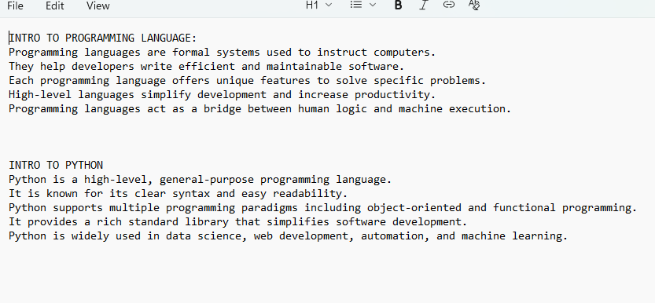
- #TASK 2
- #CREATE LOG FILE AND COUNT ERRORS
- INPUT
- 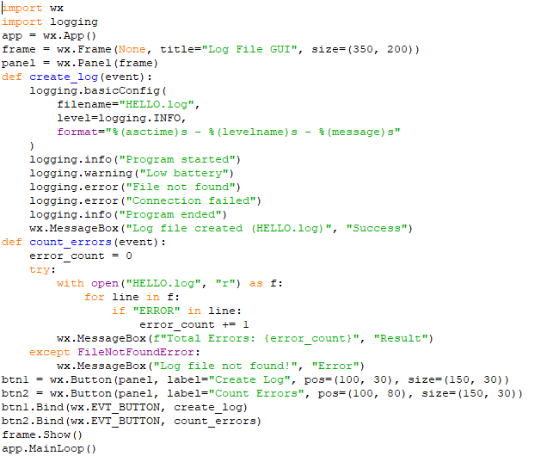
- OUTPUT
- 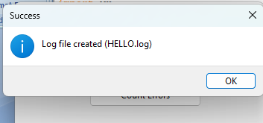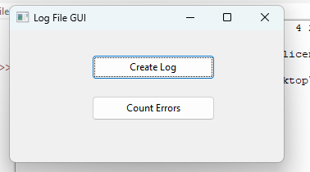
- 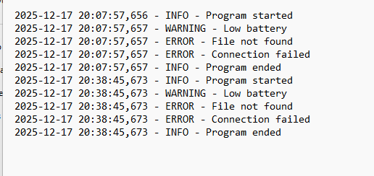

- 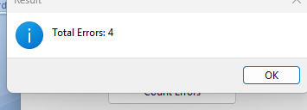

- #TASK 3
- #DISPLAY AND AND UPDATE STUDENTS RECORD
- INPUT
- 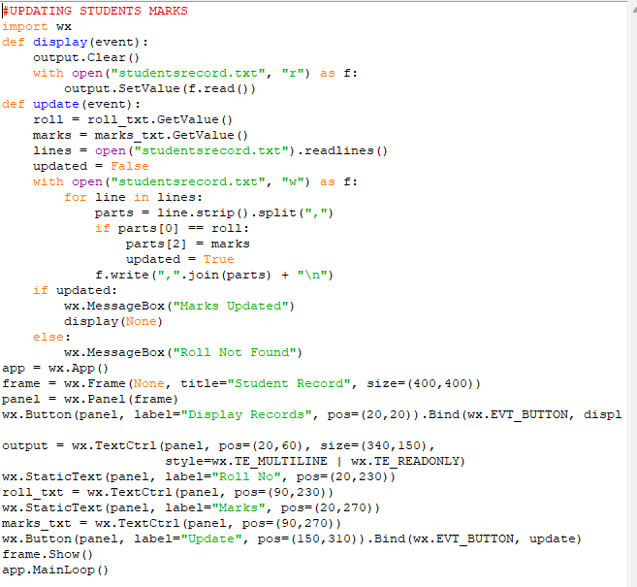

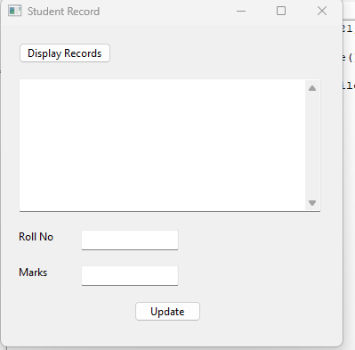

- OUTPUT

- 